**User Manual**

**User start up and Login**

* The system run on the internet using browsers, thus requires internet connection.
* On start-up it will show the home page. The user might not login but they will not be able to see the books.

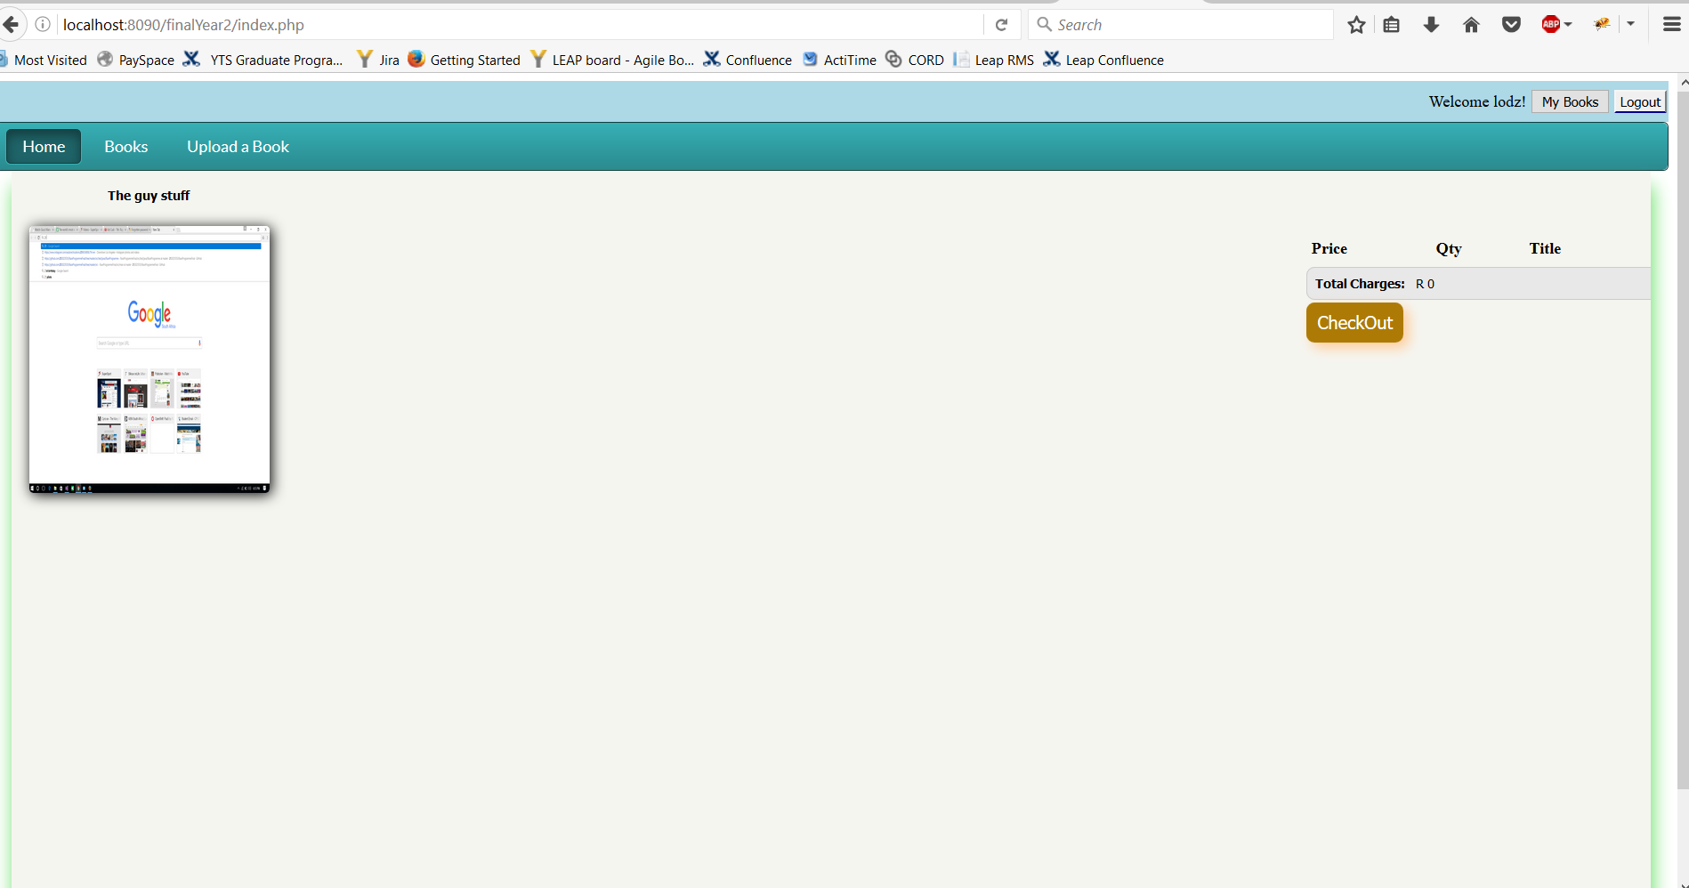

* The user will login using the login form or sign up using the sign up screen
* A user will be able to logout using the logout button on the top right corner when a user is logged in

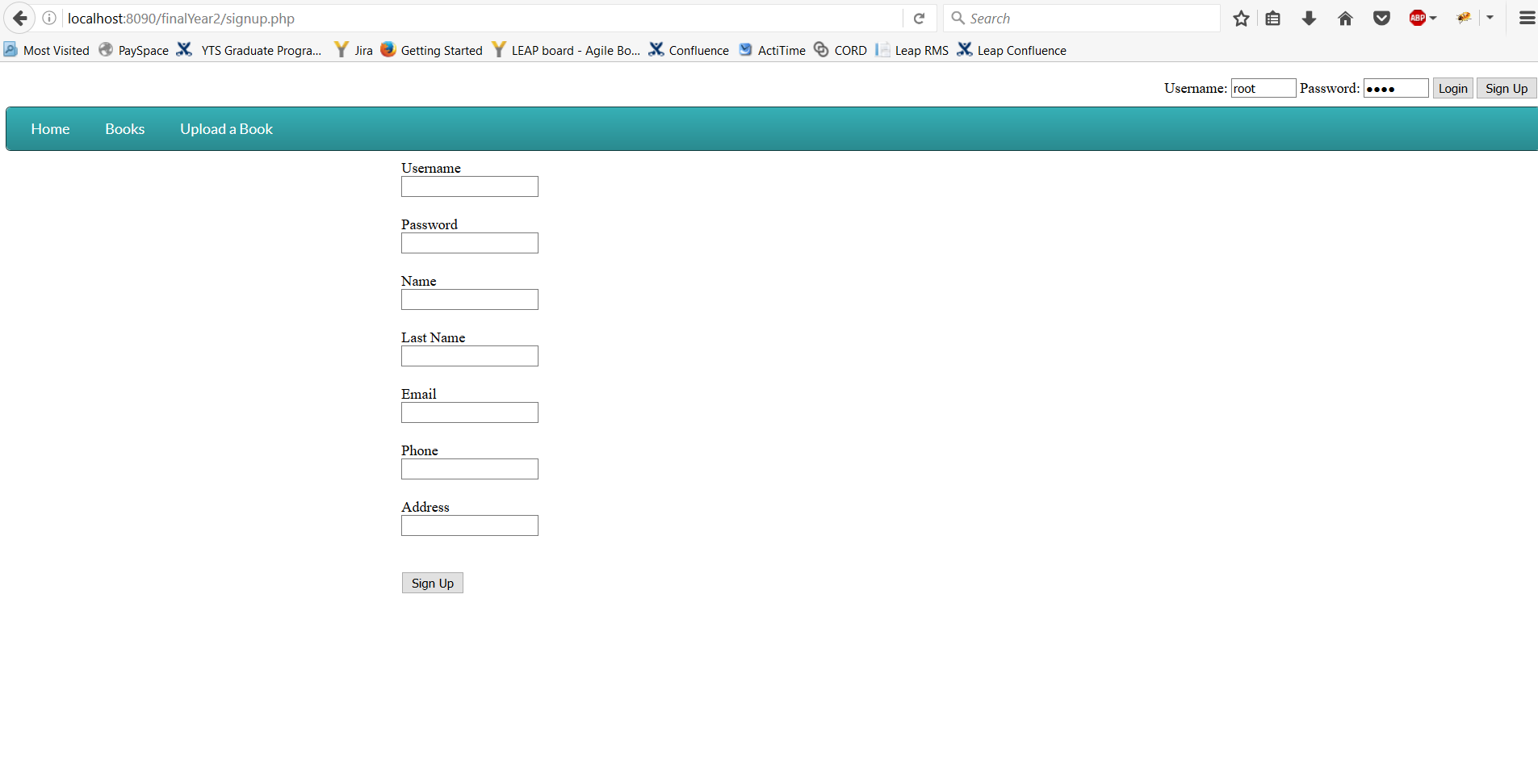

**Description of Specific Functions**

* This section contains the specific functional requirements for the online website. Here users are provided with a web interface which allows easy browsing through the different options.
* Items in the shop are organized and well-presented to ensure users can find required items easily.

View Category and Items

* Browse through the available categories and choose which book you would like to purchase.

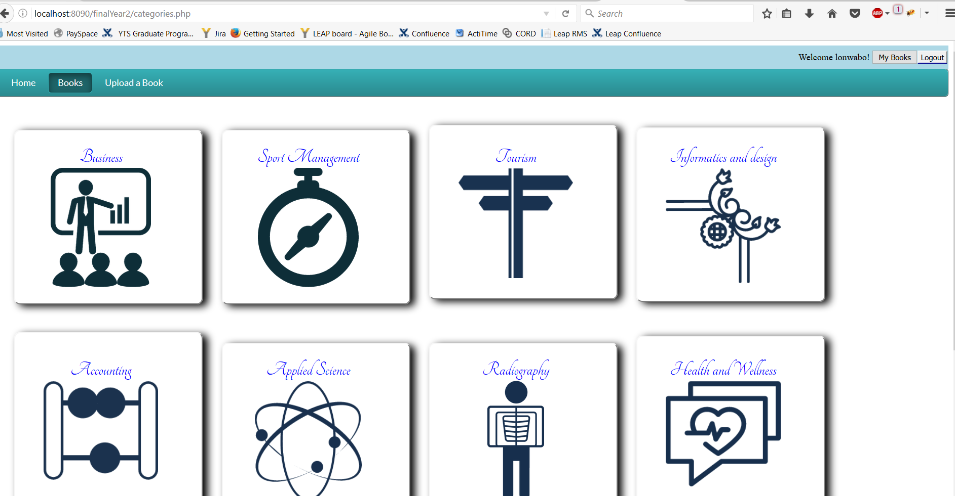

* When you want to upload a book that you want other users to purchase you can do so by clocking on the upload button.

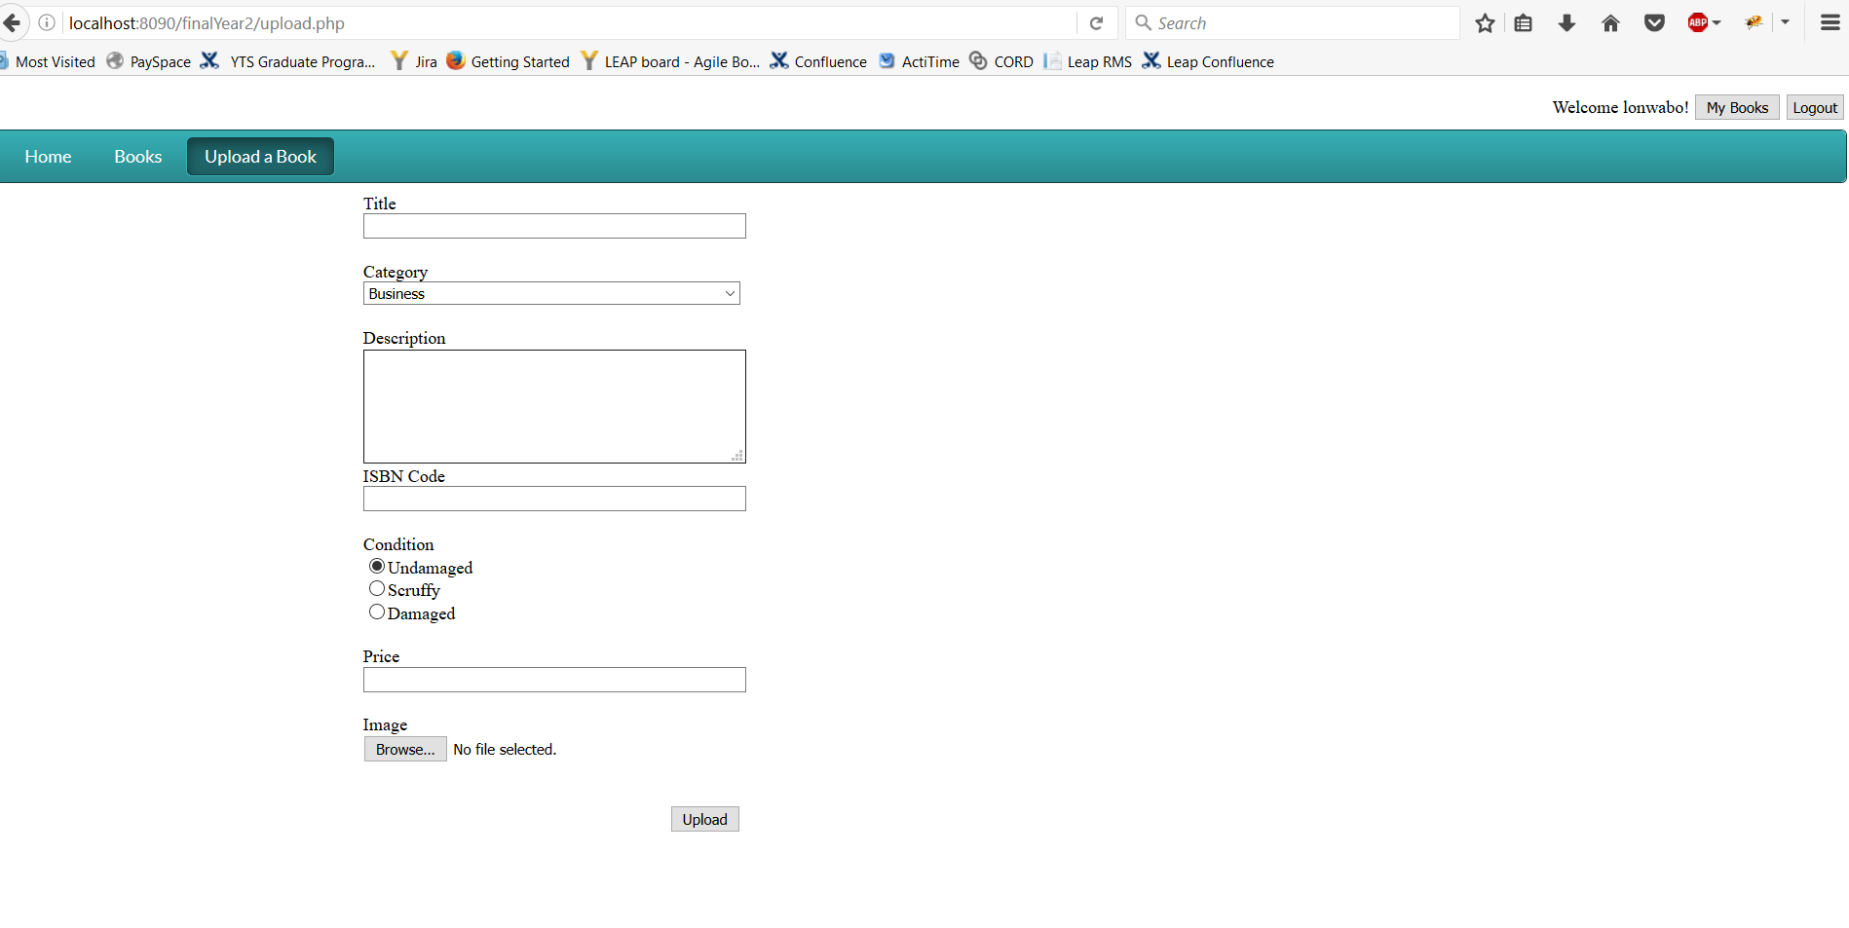

* Item checkout can be done by pressing the checkout button as it is visible in the home page.
* You can look at all the books you uploaded by pressing the “My book” button on the top right of the page.

